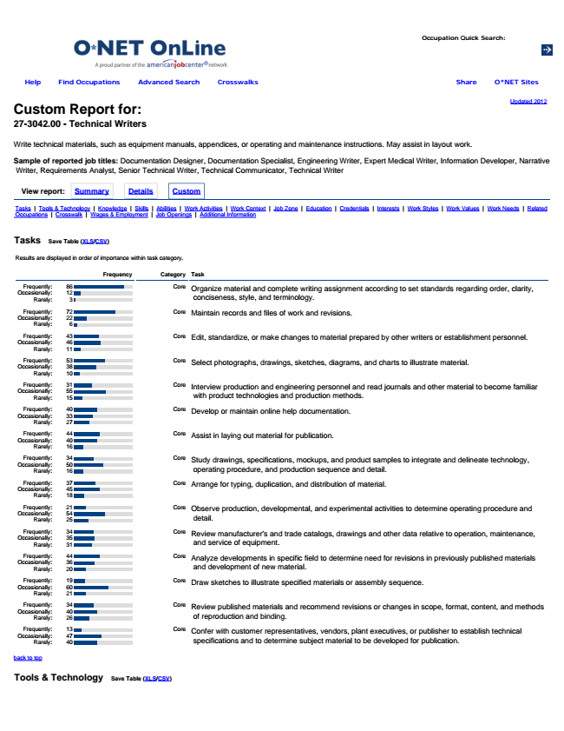

**Updated 2012 Custom Report for: 27-3042.00 - Technical Writers**

Write technical materials, such as equipment manuals, appendices, or operating and maintenance instructions. May assist in layout work.

Sample of reported job titles: Documentation Designer, Documentation Specialist, Engineering Writer, Expert Medical Writer, Information Developer, Narrative

Writer, Requirements Analyst, Senior Technical Writer, Technical Communicator, Technical Writer

**View report: Summary Details Custom**

Tasks | Tools & Technology | Knowledge | Skills | Abilities | Work Activities | Work Context | Job Zone | Education | Credentials | Interests | Work Styles | Work Values | Work Needs | Related Occupations | Crosswalk | Wages & Employment | Job Openings | Additional Information

**Tasks**

**Save Table (XLS/CSV)**

Results are displayed in order of importance within task category.

**Frequency Category Task**

Frequently: Occasionally: Rarely:

Core Organize material and complete writing assignment according to set standards regarding order, clarity,

conciseness, style, and terminology.

Frequently: Occasionally: Rarely:

86

Core Maintain records and files of work and revisions.

Frequently: Occasionally: Rarely:

72

Core Edit, standardize, or make changes to material prepared by other writers or establishment personnel.

Frequently: Occasionally: Rarely:

43

Core Select photographs, drawings, sketches, diagrams, and charts to illustrate material.

Frequently: Occasionally: Rarely:

53

Core Interview production and engineering personnel and read journals and other material to become familiar

with product technologies and production methods.

Frequently: Occasionally: Rarely:

31

Core Develop or maintain online help documentation.

Frequently: Occasionally: Rarely:

40

Core Assist in laying out material for publication.

Frequently: Occasionally: Rarely:

44

Core Study drawings, specifications, mockups, and product samples to integrate and delineate technology,

operating procedure, and production sequence and detail.

Frequently: Occasionally: Rarely:

34

Core Arrange for typing, duplication, and distribution of material.

Frequently: Occasionally: Rarely:

37

Core Observe production, developmental, and experimental activities to determine operating procedure and

detail.

Frequently: Occasionally: Rarely:

21

Core Review manufacturer's and trade catalogs, drawings and other data relative to operation, maintenance,

and service of equipment.

Frequently: Occasionally: Rarely:

34

Core Analyze developments in specific field to determine need for revisions in previously published materials

and development of new material.

Frequently: Occasionally: Rarely:

44

Core Draw sketches to illustrate specified materials or assembly sequence.

Frequently: Occasionally: Rarely:

19

Core Review published materials and recommend revisions or changes in scope, format, content, and methods

of reproduction and binding.

Frequently: Occasionally: Rarely:

34

13

Core Confer with customer representatives, vendors, plant executives, or publisher to establish technical

specifications and to determine subject material to be developed for publication.

back to top

**Tools & Technology**

**Save Table (XLS/CSV)**

**Help Find Occupations Advanced Search Crosswalks O*NET Sites Share**

12

22

46

11

38

10

55

15

33

27

40

16

50

16

45

18

54

25

35

31

36

20

60

21

40

26

47

40

3

6

**Occupation Quick Search:**

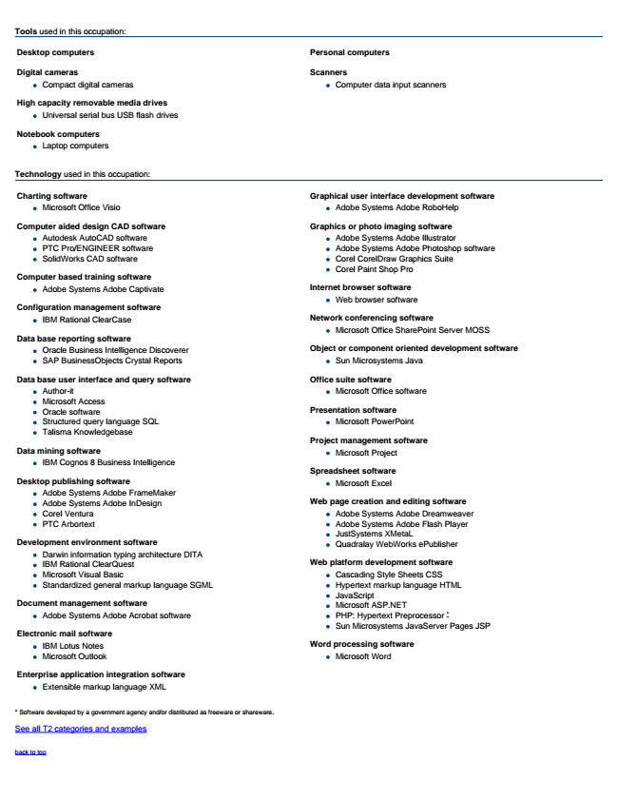

Tools used in this occupation:

**Desktop computers**

**Digital cameras**

Compact digital cameras

**High capacity removable media drives**

Universal serial bus USB flash drives

**Notebook computers**

Laptop computers

**Personal computers**

**Scanners**

Computer data input scanners

Technology used in this occupation:

**Charting software**

Microsoft Office Visio

**Computer aided design CAD software**

Autodesk AutoCAD software PTC Pro/ENGINEER software SolidWorks CAD software

**Computer based training software**

Adobe Systems Adobe Captivate

**Configuration management software**

IBM Rational ClearCase

**Data base reporting software**

Oracle Business Intelligence Discoverer SAP BusinessObjects Crystal Reports

**Data base user interface and query software**

Author-it Microsoft Access Oracle software Structured query language SQL Talisma Knowledgebase

**Data mining software**

IBM Cognos 8 Business Intelligence

**Desktop publishing software**

Adobe Systems Adobe FrameMaker Adobe Systems Adobe InDesign Corel Ventura PTC Arbortext

**Development environment software**

Darwin information typing architecture DITA IBM Rational ClearQuest Microsoft Visual Basic Standardized general markup language SGML

**Document management software**

Adobe Systems Adobe Acrobat software

**Electronic mail software**

IBM Lotus Notes Microsoft Outlook

**Enterprise application integration software**

Extensible markup language XML

**Graphical user interface development software**

Adobe Systems Adobe RoboHelp

**Graphics or photo imaging software**

Adobe Systems Adobe Illustrator Adobe Systems Adobe Photoshop software Corel CorelDraw Graphics Suite Corel Paint Shop Pro

**Internet browser software**

Web browser software

**Network conferencing software**

Microsoft Office SharePoint Server MOSS

**Object or component oriented development software**

Sun Microsystems Java

**Office suite software**

Microsoft Office software

**Presentation software**

Microsoft PowerPoint

**Project management software**

Microsoft Project

**Spreadsheet software**

Microsoft Excel

**Web page creation and editing software**

Adobe Systems Adobe Dreamweaver Adobe Systems Adobe Flash Player JustSystems XMetaL Quadralay WebWorks ePublisher

**Web platform development software**

Cascading Style Sheets CSS Hypertext markup language HTML JavaScript Microsoft ASP.NET PHP: Hypertext Preprocessor * Sun Microsystems JavaServer Pages JSP

**Word processing software Microsoft Word**

* Software developed by a government agency and/or distributed as freeware or shareware.

See all T2 categories and examples

back to top

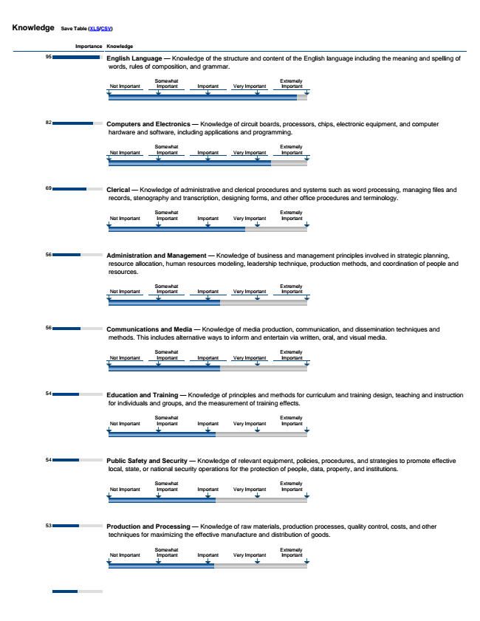

**Knowledge**

**Save Table (XLS/CSV)**

**Importance Knowledge**

95

82

69

56

56

54

54

53

English Language — Knowledge of the structure and content of the English language including the meaning and spelling of

words, rules of composition, and grammar.

Computers and Electronics — Knowledge of circuit boards, processors, chips, electronic equipment, and computer

hardware and software, including applications and programming.

Clerical — Knowledge of administrative and clerical procedures and systems such as word processing, managing files and

records, stenography and transcription, designing forms, and other office procedures and terminology.

Administration and Management — Knowledge of business and management principles involved in strategic planning,

resource allocation, human resources modeling, leadership technique, production methods, and coordination of people and resources.

Communications and Media — Knowledge of media production, communication, and dissemination techniques and

methods. This includes alternative ways to inform and entertain via written, oral, and visual media.

Education and Training — Knowledge of principles and methods for curriculum and training design, teaching and instruction

for individuals and groups, and the measurement of training effects.

Public Safety and Security — Knowledge of relevant equipment, policies, procedures, and strategies to promote effective

local, state, or national security operations for the protection of people, data, property, and institutions.

Production and Processing — Knowledge of raw materials, production processes, quality control, costs, and other

techniques for maximizing the effective manufacture and distribution of goods.

Not Important

Not Important

Not Important

Not Important

Not Important

Not Important

Not Important

Not Important

Somewhat Important

Somewhat Important

Somewhat Important

Somewhat Important

Somewhat Important

Somewhat Important

Somewhat Important

Somewhat Important

Important

Important

Important

Important

Important

Important

Important

Important

Very Important

Very Important

Very Important

Very Important

Very Important

Very Important

Very Important

Very Important

Extremely Important

Extremely Important

Extremely Important

Extremely Important

Extremely Important

Extremely Important

Extremely Important

Extremely Important

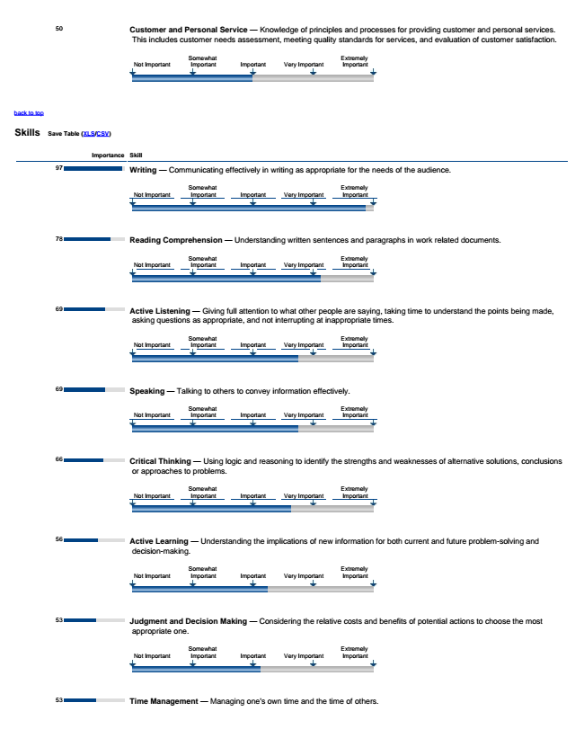

back to top

**Skills**

**Save Table (XLS/CSV)**

50 Customer and Personal Service — Knowledge of principles and processes for providing customer and personal services. This includes customer needs assessment, meeting quality standards for services, and evaluation of customer satisfaction.

**Importance Skill**

97

78

69

69

66

56

53

53

Writing — Communicating effectively in writing as appropriate for the needs of the audience.

Reading Comprehension — Understanding written sentences and paragraphs in work related documents.

Active Listening — Giving full attention to what other people are saying, taking time to understand the points being made,

asking questions as appropriate, and not interrupting at inappropriate times.

Speaking — Talking to others to convey information effectively.

Critical Thinking — Using logic and reasoning to identify the strengths and weaknesses of alternative solutions, conclusions

or approaches to problems.

Active Learning — Understanding the implications of new information for both current and future problem-solving and

decision-making.

Judgment and Decision Making — Considering the relative costs and benefits of potential actions to choose the most

appropriate one.

Time Management — Managing one's own time and the time of others.

Not Important

Not Important

Not Important

Not Important

Not Important

Not Important

Not Important

Not Important

Somewhat Important

Somewhat Important

Somewhat Important

Somewhat Important

Somewhat Important

Somewhat Important

Somewhat Important

Somewhat Important

Important

Important

Important

Important

Important

Important

Important

Important

Very Important

Very Important

Very Important

Very Important

Very Important

Very Important

Very Important

Very Important

Extremely Important

Extremely Important

Extremely Important

Extremely Important

Extremely Important

Extremely Important

Extremely Important

Extremely Important

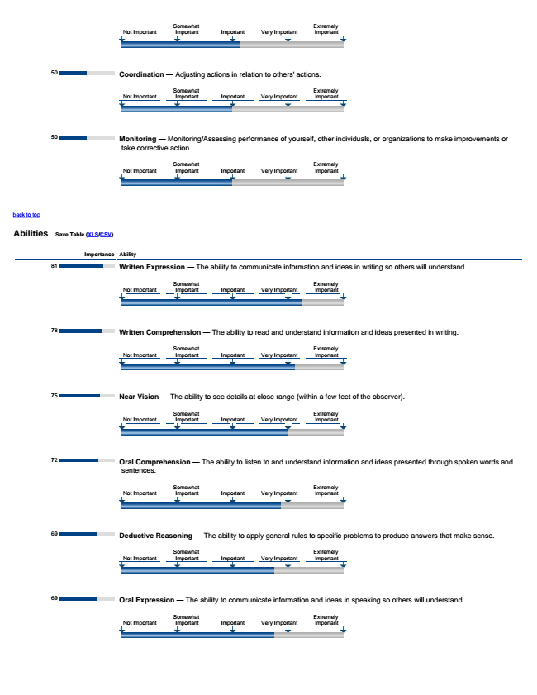

back to top

**Abilities**

**Save Table (XLS/CSV)**

50

50

**Importance Ability**

81

78

75

72

69

69

Coordination — Adjusting actions in relation to others' actions.

Monitoring — Monitoring/Assessing performance of yourself, other individuals, or organizations to make improvements or

take corrective action.

Written Expression — The ability to communicate information and ideas in writing so others will understand.

Written Comprehension — The ability to read and understand information and ideas presented in writing.

Near Vision — The ability to see details at close range (within a few feet of the observer).

Oral Comprehension — The ability to listen to and understand information and ideas presented through spoken words and

sentences.

Deductive Reasoning — The ability to apply general rules to specific problems to produce answers that make sense.

Oral Expression — The ability to communicate information and ideas in speaking so others will understand.

Not Important

Not Important

Not Important

Not Important

Not Important

Not Important

Not Important

Not Important

Not Important

Somewhat Important

Somewhat Important

Somewhat Important

Somewhat Important

Somewhat Important

Somewhat Important

Somewhat Important

Somewhat Important

Somewhat Important

Important

Important

Important

Important

Important

Important

Important

Important

Important

Very Important

Very Important

Very Important

Very Important

Very Important

Very Important

Very Important

Very Important

Very Important

Extremely Important

Extremely Important

Extremely Important

Extremely Important

Extremely Important

Extremely Important

Extremely Important

Extremely Important

Extremely Important

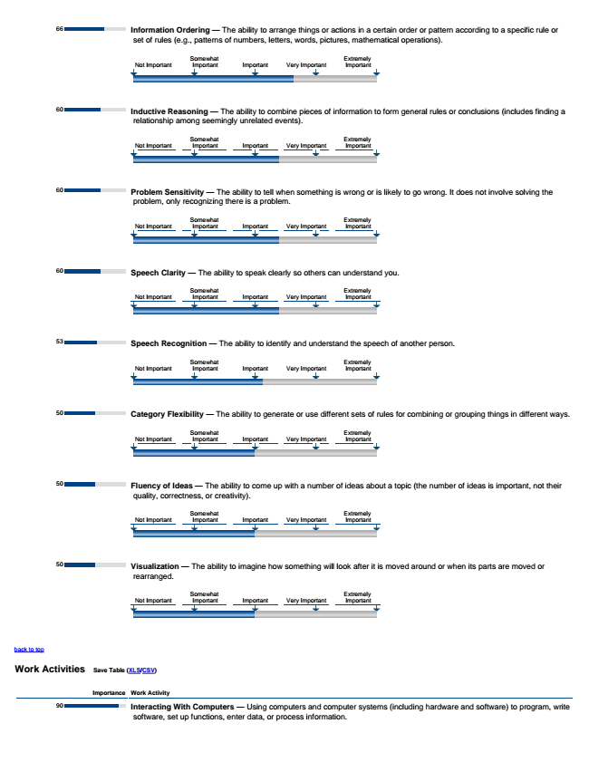

back to top

**Work Activities**

**Save Table (XLS/CSV)**

66

60

60

60

53

50

50

50

**Importance Work Activity**

90

Information Ordering — The ability to arrange things or actions in a certain order or pattern according to a specific rule or

set of rules (e.g., patterns of numbers, letters, words, pictures, mathematical operations).

Inductive Reasoning — The ability to combine pieces of information to form general rules or conclusions (includes finding a

relationship among seemingly unrelated events).

Problem Sensitivity — The ability to tell when something is wrong or is likely to go wrong. It does not involve solving the

problem, only recognizing there is a problem.

Speech Clarity — The ability to speak clearly so others can understand you.

Speech Recognition — The ability to identify and understand the speech of another person.

Category Flexibility — The ability to generate or use different sets of rules for combining or grouping things in different ways.

Fluency of Ideas — The ability to come up with a number of ideas about a topic (the number of ideas is important, not their

quality, correctness, or creativity).

Visualization — The ability to imagine how something will look after it is moved around or when its parts are moved or

rearranged.

Interacting With Computers — Using computers and computer systems (including hardware and software) to program, write

software, set up functions, enter data, or process information.

Not Important

Not Important

Not Important

Not Important

Not Important

Not Important

Not Important

Not Important

Somewhat Important

Somewhat Important

Somewhat Important

Somewhat Important

Somewhat Important

Somewhat Important

Somewhat Important

Somewhat Important

Important

Important

Important

Important

Important

Important

Important

Important

Very Important

Very Important

Very Important

Very Important

Very Important

Very Important

Very Important

Very Important

Extremely Important

Extremely Important

Extremely Important

Extremely Important

Extremely Important

Extremely Important

Extremely Important

Extremely Important

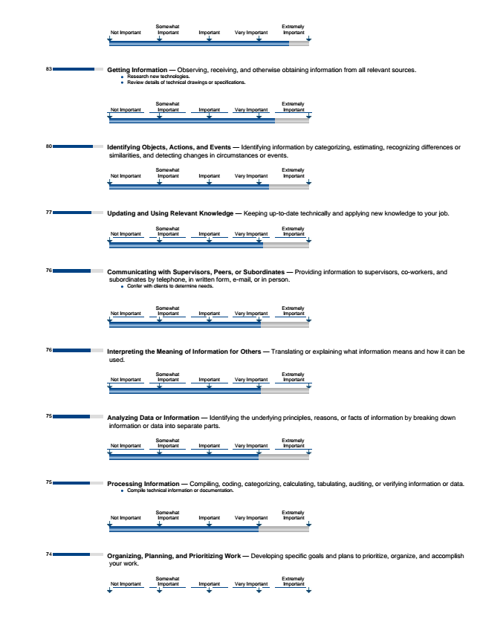

83

80

77

76

76

75

75

74

Getting Information — Observing, receiving, and otherwise obtaining information from all relevant sources.

Research new technologies. Review details of technical drawings or specifications.

Identifying Objects, Actions, and Events — Identifying information by categorizing, estimating, recognizing differences or

similarities, and detecting changes in circumstances or events.

Updating and Using Relevant Knowledge — Keeping up-to-date technically and applying new knowledge to your job.

**Communicating with Supervisors, Peers, or Subordinates — Providing information to supervisors, co-workers, and**

subordinates by telephone, in written form, e-mail, or in person.

Confer with clients to determine needs.

Interpreting the Meaning of Information for Others — Translating or explaining what information means and how it can be

used.

Analyzing Data or Information — Identifying the underlying principles, reasons, or facts of information by breaking down

information or data into separate parts.

Processing Information — Compiling, coding, categorizing, calculating, tabulating, auditing, or verifying information or data.

Compile technical information or documentation.

Organizing, Planning, and Prioritizing Work — Developing specific goals and plans to prioritize, organize, and accomplish

your work.

Not Important

Not Important

Not Important

Not Important

Not Important

Not Important

Not Important

Not Important

Not Important

Somewhat Important

Somewhat Important

Somewhat Important

Somewhat Important

Somewhat Important

Somewhat Important

Somewhat Important

Somewhat Important

Somewhat Important

Important

Important

Important

Important

Important

Important

Important

Important

Important

Very Important

Very Important

Very Important

Very Important

Very Important

Very Important

Very Important

Very Important

Very Important

Extremely Important

Extremely Important

Extremely Important

Extremely Important

Extremely Important

Extremely Important

Extremely Important

Extremely Important

Extremely Important

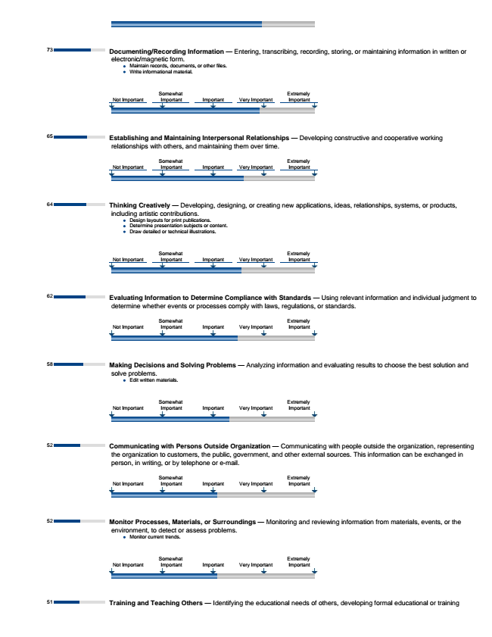

73

65

64

62

58

52

52

51

Documenting/Recording Information — Entering, transcribing, recording, storing, or maintaining information in written or

electronic/magnetic form.

Maintain records, documents, or other files. Write informational material.

**Establishing and Maintaining Interpersonal Relationships — Developing constructive and cooperative working**

relationships with others, and maintaining them over time.

Thinking Creatively — Developing, designing, or creating new applications, ideas, relationships, systems, or products,

including artistic contributions.

Design layouts for print publications. Determine presentation subjects or content. Draw detailed or technical illustrations.

**Evaluating Information to Determine Compliance with Standards — Using relevant information and individual judgment to**

determine whether events or processes comply with laws, regulations, or standards.

Making Decisions and Solving Problems — Analyzing information and evaluating results to choose the best solution and

solve problems.

Edit written materials.

Communicating with Persons Outside Organization — Communicating with people outside the organization, representing

the organization to customers, the public, government, and other external sources. This information can be exchanged in person, in writing, or by telephone or e-mail.

Monitor Processes, Materials, or Surroundings — Monitoring and reviewing information from materials, events, or the

environment, to detect or assess problems.

Monitor current trends.

Training and Teaching Others — Identifying the educational needs of others, developing formal educational or training

Not Important

Not Important

Not Important

Not Important

Not Important

Not Important

Not Important

Somewhat Important

Somewhat Important

Somewhat Important

Somewhat Important

Somewhat Important

Somewhat Important

Somewhat Important

Important

Important

Important

Important

Important

Important

Important

Very Important

Very Important

Very Important

Very Important

Very Important

Very Important

Very Important

Extremely Important

Extremely Important

Extremely Important

Extremely Important

Extremely Important

Extremely Important

Extremely Important

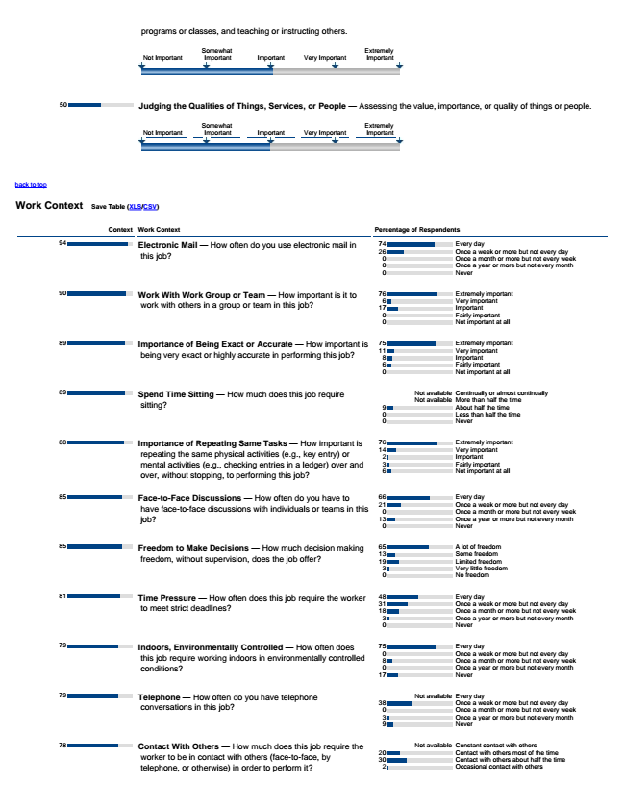

back to top

**Work Context**

**Save Table (XLS/CSV)**

**Context Work Context Percentage of Respondents**

94

Never

90

Not important at all

89

Not important at all

89

Never

88

Not important at all

85

Never

85

No freedom

81

Never

79

Never

79

Never

78

50

Electronic Mail — How often do you use electronic mail in

this job?

**Work With Work Group or Team — How important is it to**

work with others in a group or team in this job?

**Importance of Being Exact or Accurate — How important is**

being very exact or highly accurate in performing this job?

Spend Time Sitting — How much does this job require

sitting?

**Importance of Repeating Same Tasks — How important is**

repeating the same physical activities (e.g., key entry) or mental activities (e.g., checking entries in a ledger) over and over, without stopping, to performing this job?

**Face-to-Face Discussions — How often do you have to**

have face-to-face discussions with individuals or teams in this job?

**Freedom to Make Decisions — How much decision making**

freedom, without supervision, does the job offer?

Time Pressure — How often does this job require the worker

to meet strict deadlines?

**Indoors, Environmentally Controlled — How often does**

this job require working indoors in environmentally controlled conditions?

Telephone — How often do you have telephone

conversations in this job?

Contact With Others — How much does this job require the

worker to be in contact with others (face-to-face, by telephone, or otherwise) in order to perform it?

Judging the Qualities of Things, Services, or People — Assessing the value, importance, or quality of things or people.

programs or classes, and teaching or instructing others.

Not Important

Not Important

Somewhat Important

Somewhat Important

Important

Important

Very Important

Very Important

Extremely Important

Extremely Important

Every 74

day 26

76

Very important 17

Extremely 75

important 11

Extremely 76

important 14

Every 66

day 21

Once a month or more but not every week 13

A 65

lot of freedom 13

Some freedom 19

Every 48

day 31

Once a week or more but not every day 18

75

Once a year or more but not every month 17

Not available Every day 38

Not available Constant contact with others 20

Contact with others most of the time 30

Once a week or more but not every day 0

Once a month or more but not every week 0

Once a year or more but not every month 0

Extremely important 6

Important 0

Fairly important 0

Very important 8

Important 6

Fairly important 0

Not available Continually or almost continually Not available More than half the time 9

About half the time 0

Less than half the time 0

Very important 2

Important 3

Fairly important 6

Once a week or more but not every day 0

Once a year or more but not every month 0

Limited freedom 3

Very little freedom 0

Once a month or more but not every week 3

Once a year or more but not every month 0

Every day 0

Once a week or more but not every day 8

Once a month or more but not every week 0

Once a week or more but not every day 0

Once a month or more but not every week 3

Once a year or more but not every month 9

Contact with others about half the time 2

Occasional contact with others

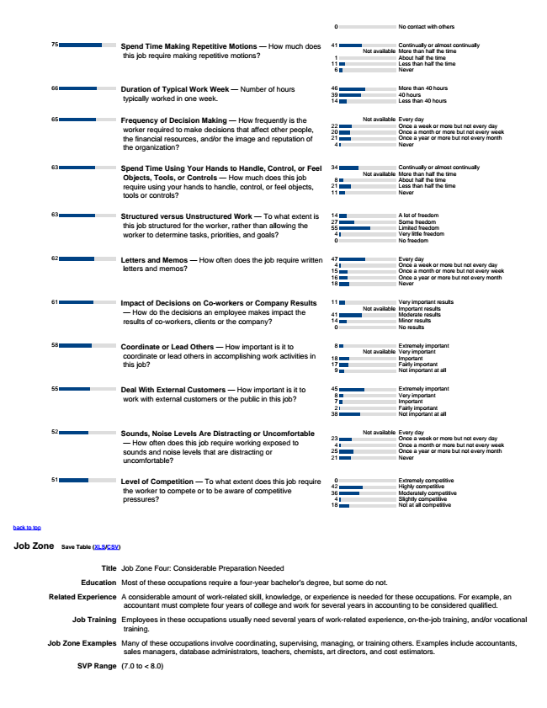

Not at all competitive

back to top

**Job Zone**

**Save Table (XLS/CSV)**

Title Job Zone Four: Considerable Preparation Needed

Education Most of these occupations require a four-year bachelor's degree, but some do not.

Related Experience A considerable amount of work-related skill, knowledge, or experience is needed for these occupations. For example, an

accountant must complete four years of college and work for several years in accounting to be considered qualified.

Job Training Employees in these occupations usually need several years of work-related experience, on-the-job training, and/or vocational

training.

Job Zone Examples Many of these occupations involve coordinating, supervising, managing, or training others. Examples include accountants,

sales managers, database administrators, teachers, chemists, art directors, and cost estimators.

SVP Range (7.0 to < 8.0)

No contact with others

75

Never

66

Less than 40 hours

65

Never

63

Never

63

No freedom

62

Never

61

No results

58

Not important at all

55

Not important at all

52

Never

51

**Spend Time Making Repetitive Motions — How much does**

this job require making repetitive motions?

**Duration of Typical Work Week — Number of hours**

typically worked in one week.

**Frequency of Decision Making — How frequently is the**

worker required to make decisions that affect other people, the financial resources, and/or the image and reputation of the organization?

**Spend Time Using Your Hands to Handle, Control, or Feel**

Objects, Tools, or Controls — How much does this job require using your hands to handle, control, or feel objects, tools or controls?

**Structured versus Unstructured Work — To what extent is**

this job structured for the worker, rather than allowing the worker to determine tasks, priorities, and goals?

Letters and Memos — How often does the job require written

letters and memos?

**Impact of Decisions on Co-workers or Company Results**

— How do the decisions an employee makes impact the results of co-workers, clients or the company?

**Coordinate or Lead Others — How important is it to**

coordinate or lead others in accomplishing work activities in this job?

**Deal With External Customers — How important is it to**

work with external customers or the public in this job?

**Sounds, Noise Levels Are Distracting or Uncomfortable**

— How often does this job require working exposed to sounds and noise levels that are distracting or uncomfortable?

Level of Competition — To what extent does this job require

the worker to compete or to be aware of competitive pressures?

41

About half the time 11

More 46

than 40 hours 39

40 hours 14

Not available Every day 22

Once a week or more but not every day 20

Once a month or more but not every week 21

34

About half the time 21

Less than half the time 11

A 14

lot of freedom 27

Some freedom 55

47

Once a week or more but not every day 15

Once a month or more but not every week 16

Once a year or more but not every month 18

Very 11

important results Not available Important results 41

Moderate results 14

Extremely important Not available Very important 18

Important 17

45

Fairly important 38

Not available Every day 23

Once a month or more but not every week 25

Once a year or more but not every month 21

Extremely competitive 42

Highly competitive 36

Slightly competitive 18

0

Continually or almost continually Not available More than half the time 1

Less than half the time 6

Once a year or more but not every month 4

Continually or almost continually Not available More than half the time 8

Limited freedom 4

Very little freedom 0

Every day 4

Minor results 0

8

Fairly important 9

Extremely important 8

Very important 7

Important 2

Once a week or more but not every day 4

0

Moderately competitive 4